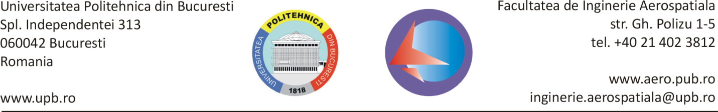

Work Agreement to the Final Project for the University Year 2016-2017

Agreement parties:
Student: __________________________________________________________________________
E-mail: ___________________________________________ Mobil: __________________________
in my final year of the Air Navigation program of studies
knowing the provisions of the Procedura de Elaborare și Îndrumare a Proiectelor de Diplomă UPB-FIA Edition 1.3, and the provisions of the UPB rules, agreeing to fully comply, I undertake the responsibility to work proportionally with 18 CP, for 2 Semesters, for my final project on the type a / b / c subject:
__________________________________________________________________________________
__________________________________________________________________________________
under the supervision of
Supervisor (on behalf of UPB-FIA): ______________________________________________________
E-mail: ___________________________________________ Mobil: ___________________________
Where do student and supervisor meet: _________________________________________________
Co-supervisor (if applicable): __________________________________________________________
Co-supervisor organisation: ___________________________________________________________
I, the undersigned student, am commited to undertake the following checks and to deliver the final project on the deadlines indicated in the following table. Delays will be sanctioned by mark penalties or by canceling of this agreement. In case of canceling, I am aware that I will miss my Diploma Exam in the current university year (both July and September sessions).

Table with check phases and delivery of the final project and deadlines (table is filled at the end of each phase):
No | Delivery | Deadline (planned) | Actual delivery date | Mark | Credit Points | Supervisor’s signature
1 | Check 1 (documentary study, references, work plan) | 25 Nov 2016 |  | P₁ (0-50)
2 | Check 2 (at least 33% of the project and at least one Chapter) | 20 Jan 2017 |  | P₂ (0-50)
3 | Mark for the Project Preparation in Semester I (PP1) | 23-25 Jan 2017 |  | Round[(P₁+P₂)/10] | 4
4 | Check 3 (at least 66% of the project and work quality for max points) | 31 Mar 2017 |  | P₃ (0-50)
5 | Check 4 (at least 90% of the project and work quality for max points) | 19 May 2017 |  | P₄ (0-50)
6 | Mark for the Project Preparation in Semester II (PP2) | 29-31 May 2017 |  | Round[(P₃+P₄)/10] | 4
7 | Definitive Final Project delivery | 16 Jun 2017 |  | - | -
8 | Undertaking of the Diploma Exam in the Board | 3-7 Jul 2017 |  |  | 10 | -

Student | Supervisor (UPB-FIA) | Departament Director
Name: | Name: | Name:
Signature: | Signature: | Signature:
Date: | Date: | Date:

